# VAT Project

This process to run 1st of every month, Emma Turley [Emma.turley@collinsongroup.com](mailto:Emma.turley@collinsongroup.com) drops input files on below location and she confirms if it need to add cost centre or any lounge data like this.  
  
  
  
If there is any cost centre, Lounge code data needs to add it require to add in below table on DI-BILLING server

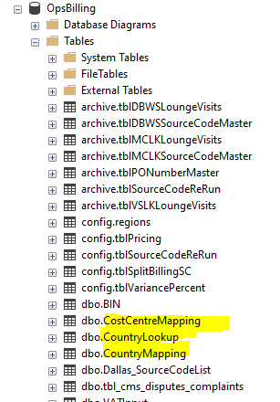  
  
After this copy all input files on below location  
  
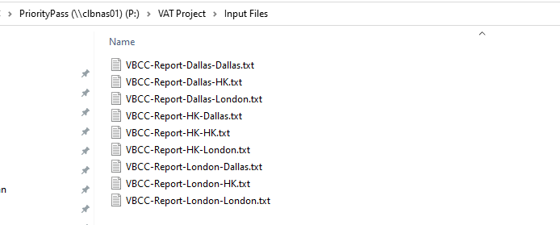

Run below Alteryx workflow   
  
<http://10.204.210.202:1433/gallery/#!app/VAT-Project-Summary-v1---EU-without-Unique/63b408d5701c98b0ac43557a>  
  


At end of successful execution, it will generate files on below location, share all files to Emma which generated on same day.  
  
